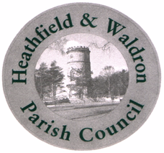

HEATHFIELD AND WALDRON PARISH COUNCIL

CLERICAL OFFICER

Salary SCP 18 within scale SCP 18 - 23 £31,537 - £34,434 (fte)
16 hours per week. 23 + 2 days annual leave. Local Government Pension scheme (after probation period)

Applications are invited from suitably qualified and experienced persons for the part-time position of Clerical Officer. Applicants must have a good general level of education including English and Maths at grade C or above. Prior experience of events or other project management would be an advantage. Excellent administration, IT and communication skills are essential. The post involves occasionally working at the weekend and evenings when an event is being held or there is an evening meeting.

The Council serves a population of approximately 12,000 with a precept in excess of £500,000 and is an active and progressive authority.

The Council is committed to the development of its employees and offers training for the successful applicant to obtain their Introduction to Local Council Administration (ILCA), if they don’t already have this, along with other training opportunities. We also work hard on improving the Wellbeing of our staff. You will need to have a positive and friendly outlook, be hardworking and reliable and be able to work effectively as part of a small team and on your own initiative.

Please note - successful applicants will be required to attend for interview on 12th August 2026.

Closing date for applications: Noon on 6th August 2026
Date of Interviews: 12th August 2026

For an application pack, please contact

Miss H Johnson,
Clerk to the Council
Heathfield and Waldron Parish Council
73 High Street
Heathfield
East Sussex
TN21 8HU

Tel: 01435 865700
Email clerk@hw-pc.gov.uk
www.hw-pc.gov.uk

