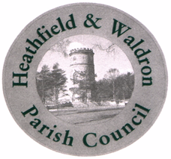

HEATHFIELD AND WALDRON PARISH COUNCIL

Person Specification July 2026 – Clerical Officer

Essential |  |  | Preferable
Education | Good general education with a minimum of 5 GCSEs, including English and Maths at Grade C or above (or equivalent) | Introduction to Local Council Administration (ILCA)
Experience | Experience of compiling agendas, taking and producing minutes  Experience of running projects, researching and keeping to budgets. | Experience of dealing with members of the public and organising volunteers  Experience of the burial process and of managing a burial site
Skills, knowledge and aptitude | Minute taking, excellent IT skills, general administration and record keeping  Ability to produce reports on various subjects having undertaken research prior to this  Able to communicate with people from different sectors  Good time management skills and ability to problem solve  Ability to employ discretion and maintain confidentiality Knowledge of Word, Excel, and Power Point | Knowledge of health and safety legislation and risk management issues
Personal qualities | Must be able to work under pressure and to tight deadlines  Must be self-motivated, honest and trustworthy  Must be able to maintain good relationships with Councillors, other staff, contractors and the general public  Must be adaptable and able to work effectively in a small team  Must have methodical and thorough approach to tasks and be able to anticipate problems and solve them | Willingness to undertake training and to act as the Council’s representative at meetings and other official occasions when required
Other | Must be able to attend the occasional evening meeting and when an event is being held, which would normally be at the weekend. Must have full driving licence with relevant insurance cover to allow for occasional business use or be prepared to add this to their insurance cover.

