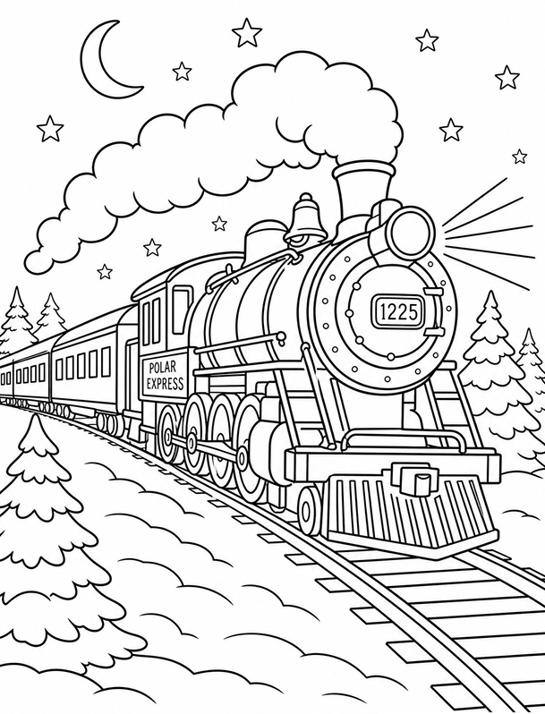

Would You Like to Turn on Heathfield and Waldron Parish Council’s Christmas Lights?

We’re excited to launch our Christmas Colouring Competition, running from 19th October to 13th November!

🎄 One lucky winner will be chosen to switch on the Town’s Christmas lights on Friday 20th November at 4:30pm 🎄
🏆 The winner will also receive a small prize, along with two runner-ups!

All entries will be displayed in the Parish Council office window, brightening up the High Street for the festive season and spreading Christmas cheer to everyone passing by.

How to Enter:
- A selection of colouring templates has been shared with local schools.
- Download templates from our website: www.hw-pc.gov.uk/events/christmas-lighting-up-2026
- Collect them from the Parish Council office.

Once completed, please drop your entry off at:
📍 Heathfield and Waldron Parish Council Office
73 High Street, Heathfield, East Sussex, TN21 8HU

Competition Details:
- Open to children aged 3–11
- Judged in three age categories: 3–5 years, 6–8 years and 9–11 years
- Entries accepted from 19th October to 13th November
We can’t wait to see your amazing artwork—get colouring and help light up Heathfield this Christmas!

Using the space below please fill out the details so we are able to contact you if you are a winning entry.

Name:

Age:

Contact Details:

